



**Fundamentals of Computing (CS4051NP)**

**Sandip Dhakal**

**Course Work**

**GROUP - C1**

**2025, Spring**

**Informatics College Pokhara**

**Submitted By -:**

**BIBEK POUDEL (24041079)**

**May - 4, 2025**

**Turnitin Similarity Report**

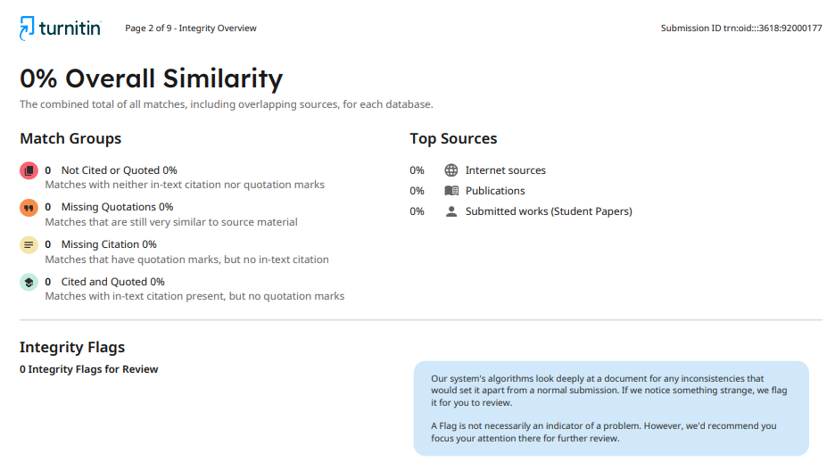

Figure 1 : Turnitin Similarity Report

Table of Contents

1 Introduction 3

1.2 Project Overview 3

1.3 Features 3

1.4 Aims & Objective 4

1.5 Technology Used 4

2 Data Structures 6

3 Algorithm 8

4 Flowchart 11

5 Conclusion 12

# 1 Introduction

## 1.2 Project Overview

This is a skin care store system where admin of system can see product detail, update stock, can sell product easily etc. This is python-based system designed for WeCare a local supplier to assist them to run their daily business easily. In this system, when user buys 3 items then he/she will get 1 item for free. Admin of system can generate invoices in proper structure for customer easily after sale completed. This system currently works on CLI (Command Line Interface), we are focused on features, GUI part will be implemented soon.

This system read data from products.txt file then stores data in dictionary of list then displays in proper format so that user can understand easily. We have stored product detail like id, name, price, stock, etc. This system is in beta phase, we will add new features, GUI part soon.

## 1.3 Features

**i. Data stored in PC local file**

In this system, data is fetched from local file from PC of admin. We used file method and read data from it then stored it in list then we displayed. We have used try catch block to handle error related file.

**ii. Better user interface**

We have made better user interface in CLI. We have displayed data and message from proper format. In CLI, user interface is clear and displayed proper message based on condition so that user can use it easily.

**iii. Invoice Generation**

It selling completed to customer then invoice/bill will be generated as new file and stored in proper format.

**iv. Sell / Restock Product**

In this system, admin can sell product and restock product by click in number given in message. By this it makes easy to handle or track large stock easily.

**v. Industry Standard Code Writing**

We have written code in proper way so that new developer can understand it easily and add, remove & update code. We have divided each feature in different function and sub function.

## 1.4 Aims & Objective

i. To make easier for admin to handle big stock easily.

ii. To make the store more digital and organized.

iii. To display available product in proper format.

iv. To make admin to sell and add product in easy way.

v. To make better user interface for admin.

vi. To generate bill after sale complete.

## 1.5 Technology Used

**i. Python**



Figure 2 : Python Logo

We used Python language to build this system because Python is easy to use and learn by its easy syntax. In this project we used Python 3.13 because we can use newer features. Python is dynamic language, we can store any type of data in any variable or collection, so it makes easier to handle data.

**ii. JetBrains PyCharm**



Figure 3 : PyCharm Logo

We used PyCharm as a ide because it gives more specific features to build python program. It helps us in different ways like completion or suggestion of code, gives warning when written unnecessary code, debugging, error highlighting, gives proper documentation on hover on method or others. By this it saves more time and help to make to write more optimized code.

**iii. Microsoft Word**



Figure 4 : Microsoft Word

We used MS-Word for writing our documentation part of project. All documentation part like cover page to conclusion were made using MS-Word. It preserves quality of any image and gives multiple features so we can make our documentation in easy and fast. It makes our documentation well-structured and formatted.

# 2 Data Structures

We have used different data strictures in python like string, list, dictionary, tuple etc. It helps to manage and organize code in proper format so that data is easier to handle. In this project, we used data project to update stocks, sell products, store products, etc. Following are the some data structures that we’ve used in our system.

1. **List**

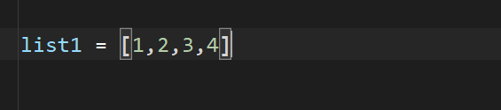

Figure 5 : Syntax of List

List in Python is used to data or value of any datatype. In this project, we stored products in List. Products list stored multiple dictionary, each dictionary stores details of each product. We used list because it allows us to iterate over list and we can access each product detail in easy. By keeping products into lists we can do CRUD operation in easy way. By this we also can add, sort, products detail. In short, we used list because it is mutable and it is ordered collection so that we can access data via index.

1. **Dictionary**

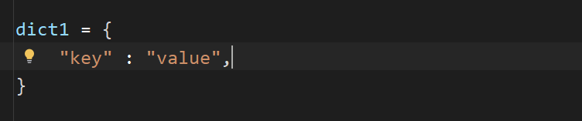

Figure 6 : Syntax of Dictionary

Dictionary is a data structure in python which allows us to store information in key & value. In this system used dictionary to store detail of each product in key-value. We stored products id, name, stock, price & country. By this, it makes us to access data in easy way. Dictionary makes our code clear and easier to understand so it help developer to modify code in easy. It groups related data of each product in single unit so it help us to handle big data easily, it is mutable so update is possible.

1. **String**

String is a data type which store text mean it can store almost everything which exist in our keyboard. We can use string by using “ ”, ‘ ’, “”” ”””, ‘’’ ‘’’. It is also called array of character. In project we used string in everywhere like when fetching data from file, while printing data in CLI, to store product details, etc. In short we used it to manage and process text data.

We have selected List, Dictionary, String, etc for our system because they are simple, easy, readable, perfect to handle large data, etc. List helps us to store large data and we can keep other data structures inside list, and it is easy to handle by its methods. Dictionary allow us to keep similar data in a single unit, like each product in single variable. We can store it in key pair so it is easy to handle and it is readable. Both list and dictionary are mutable so we can do CRUD operation too. String also helps us to handle text data. Because of these data structures it made our work fast and easy.

# 3 Algorithm

Algorithm WeCare Skin Care System

Step 1 : Start

Step 2 : Read products from file "product.txt" store it in  Products = list of dictionary

Step 3 : Display welcome message & main menue:

           1. Show Available Products

           2. Process Sale

           3. Restock Product

           4. Exit

Step 4 : Input choice from user

           Step 4.1 : If input != integer then display error and go to Step 3

           Step 4.2 : If input is an integer, go to Step 5

step 5 : if input == 1 then

            go to step 6

         otherwise if input == 2 then

            go to step 7

         otherwise if input == 3 then

            go to step 8

         otherwise if input == 4 then

            go to step 9

         otherwise

            go to step 10

step 6 :

        step 6.1 : Display product with ID, name, price, no of free items and stock in table

        step 6.2 : go to step 3

step 7:

    step 7.1 : Input customer name

    step 7.2 : goto step 6

    step 7.3 : Input product ID

    step 7.4 : If not product id found, then

                  display "Invalid Product ID"

                  goto step 7.3

    step 7.5 : Input quantity to sell

    step 7.6 : If quantity < 0 then

                  display "Invalid quantity"

                  goto step 7.5

    step 7.8 : If quantity + free items > stock then

                  display "Not enough stock"

                  goto step 7.3

    step 7.9 : Update product updated stock

    step 7.10: Generate sales invoice to folder "invoices"

    step 7.11: Update product data in products.txt file from updated stock

    step 7.12: goto step 3

step 8:

        step 8.1 : Input supplier name

        step 8.3 : Input product ID

        step 8.4 : If not product found then

                    display "Invalid Product ID"

                    goto step 8.3

        step 8.5 : Input quantity to restock

        step 8.6 : If quantity < 0 then

                    display "Invalid quantity"

                    goto step 8.5

        step 8.7 : Input cost price

        step 8.8 : If cost price < 0 then

                    display "Invalid cost price"

                    goto step 8.7

        step 8.9 : Update price & stock of product

        step 8.10: Update cost price in products.txt file

        step 8.11: Generate and save restock invoice to folder "invoices"

        step 8.12: goto step 3

step 9 : Display "Thank you"

    go to step 11

step 10 : Display "Invalid option! Please choose between 1 to 4 only"

    go to step 3

step 11 : Stop

# 4 Flowchart

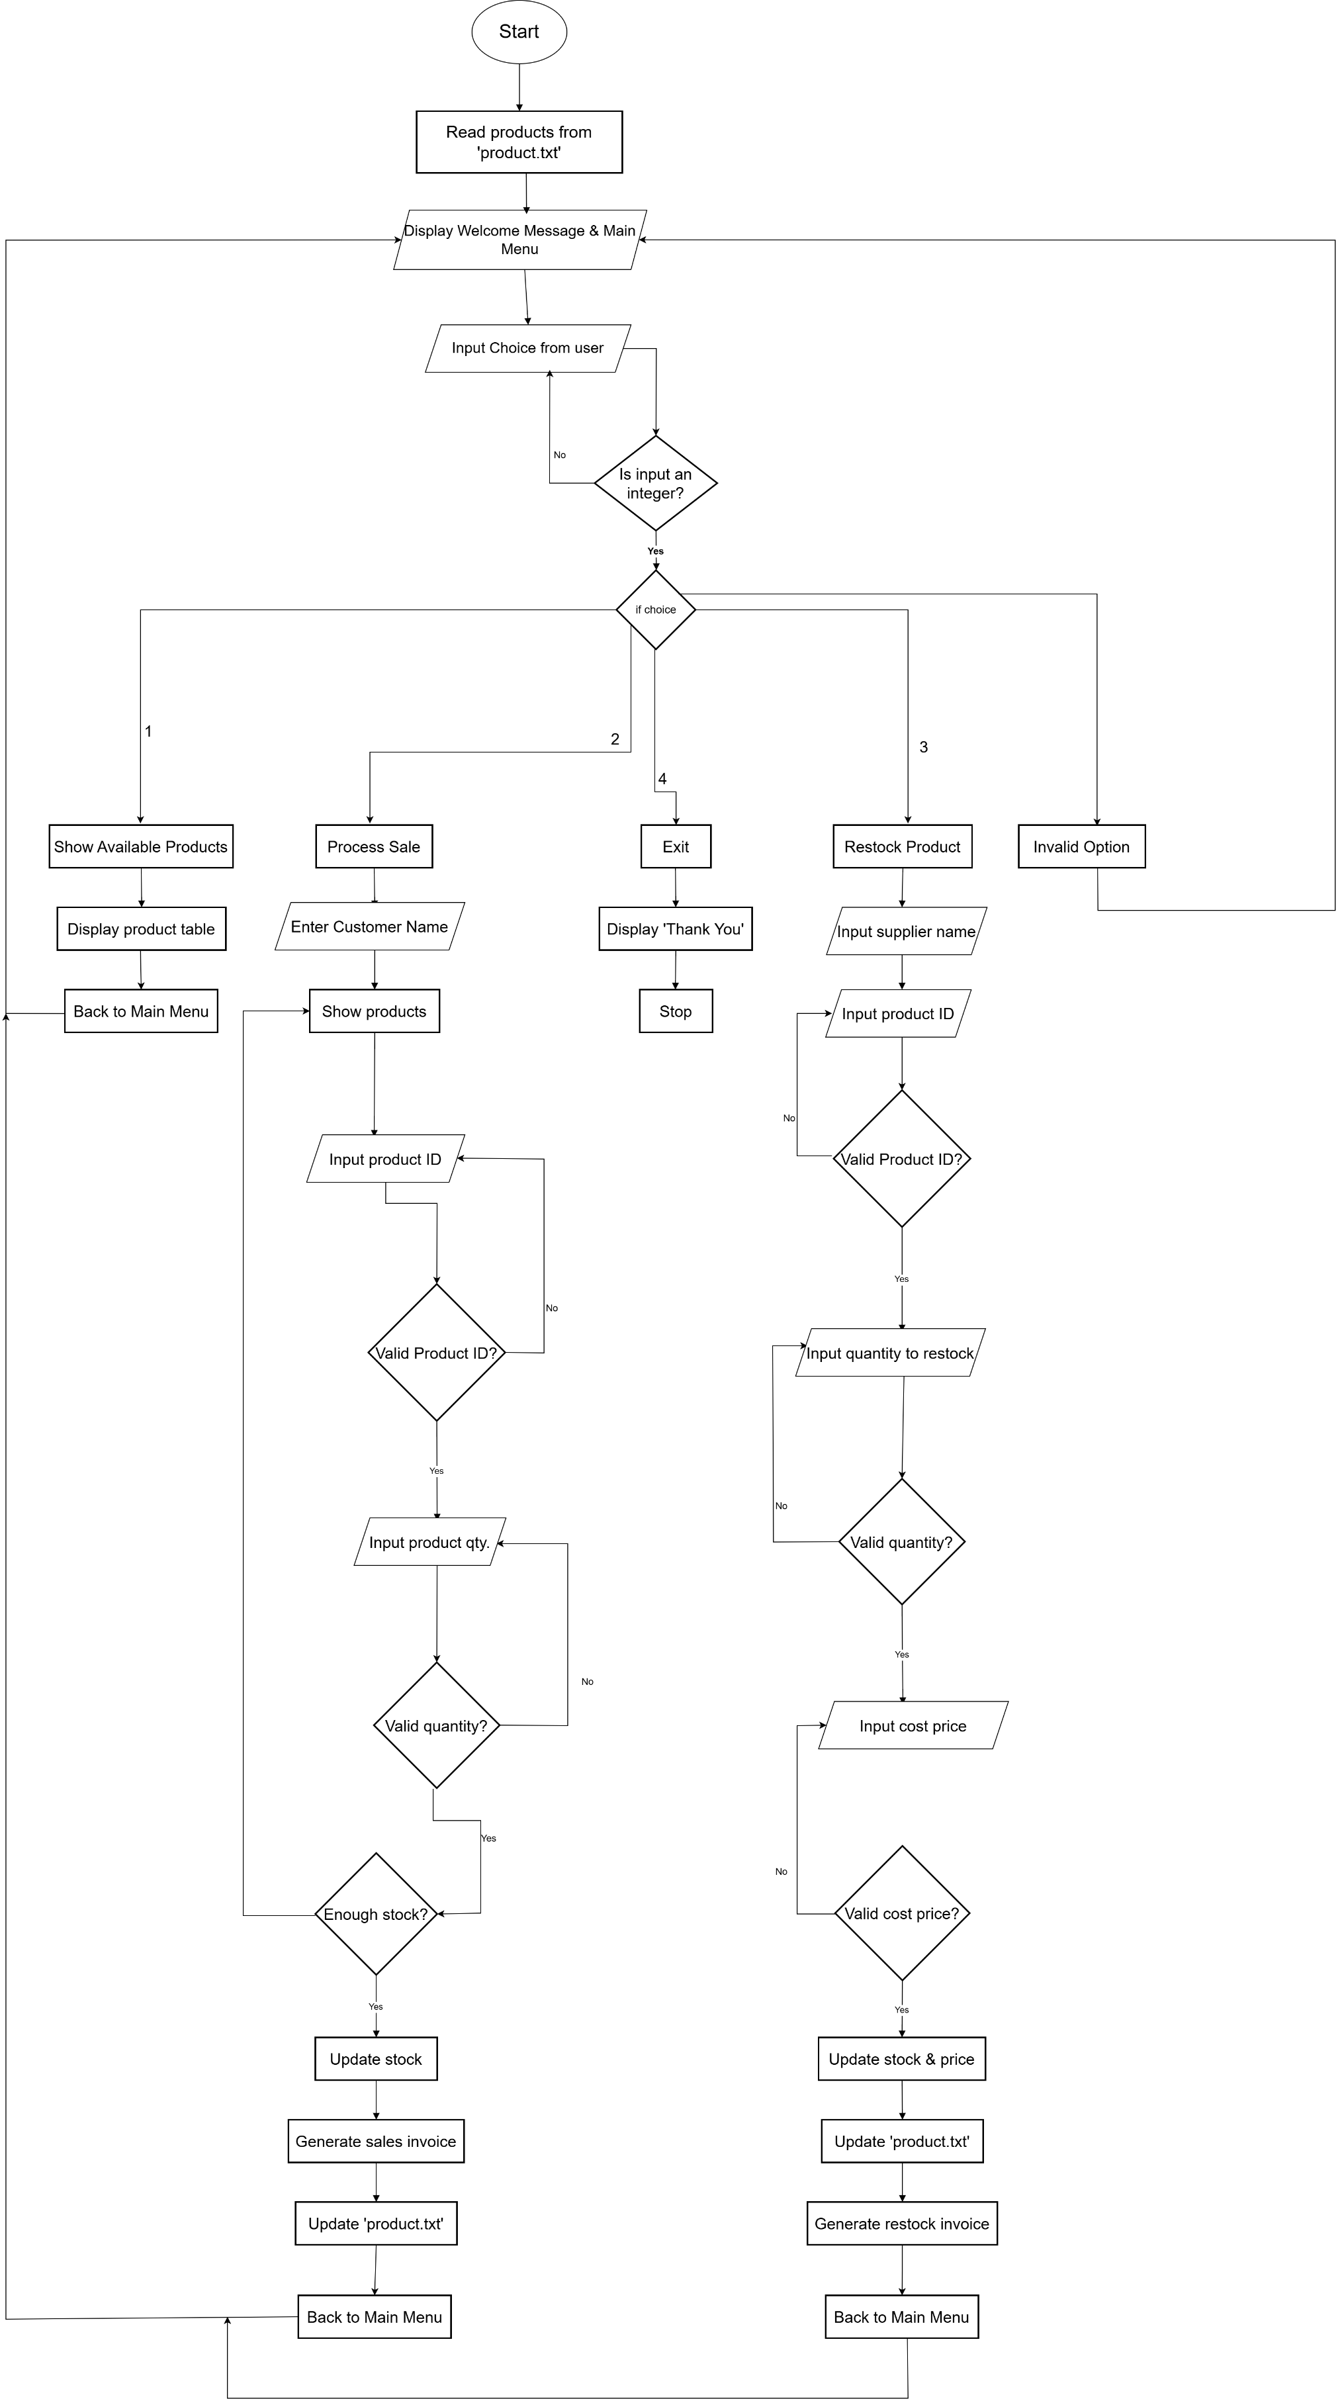

Figure 7 : Flowchart

# 5 Conclusion

We Care Skin Care System provide amazing features so that admin of system can easy use of system and can display, update restock and sale product. All the data stored in computer local file products.txt. It will make local vendor to manage their day-to-day operation in easy. In this system admin can generate invoices/bills after sales completed in proper format.

Throughout the project, we used python concept to build this system. We used different concept of python like functions, file handling, loop, if-else, list, dictionary, string and other many more. Currently this system is in beta phase, some of other features are not allowed but they will be added in future. While building this project we have learned lots of new thing and we have completed the basics of python.